APPENDIX A
PHOTOGRAPHS TAKEN DURING JIV AT 18” TEBIDABA-BRASS PIPELINE AT KALATORU COMMUNITY, SOUTHERN IJAW L.G.A, BAYELSA STATE ON 4TH MAY, 2024.
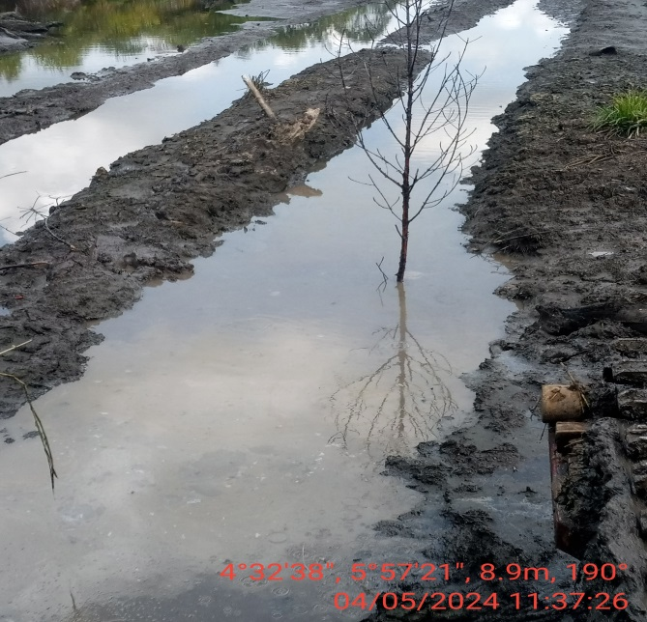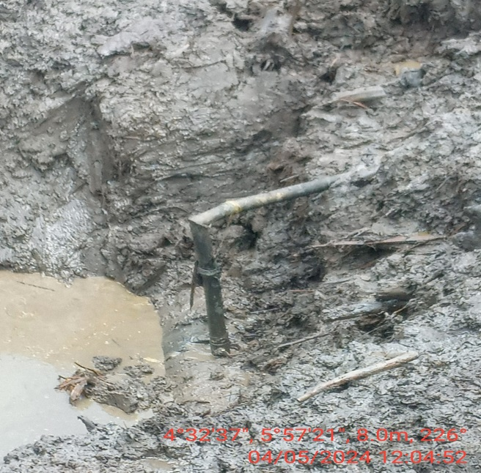
Fig. 1: Incident point before exaction. Fig. 2. 2” valve installed at 12 o’ clock position.

